**Errors**

1. Even though we are taping on the next page its not moving to the next page and showing same

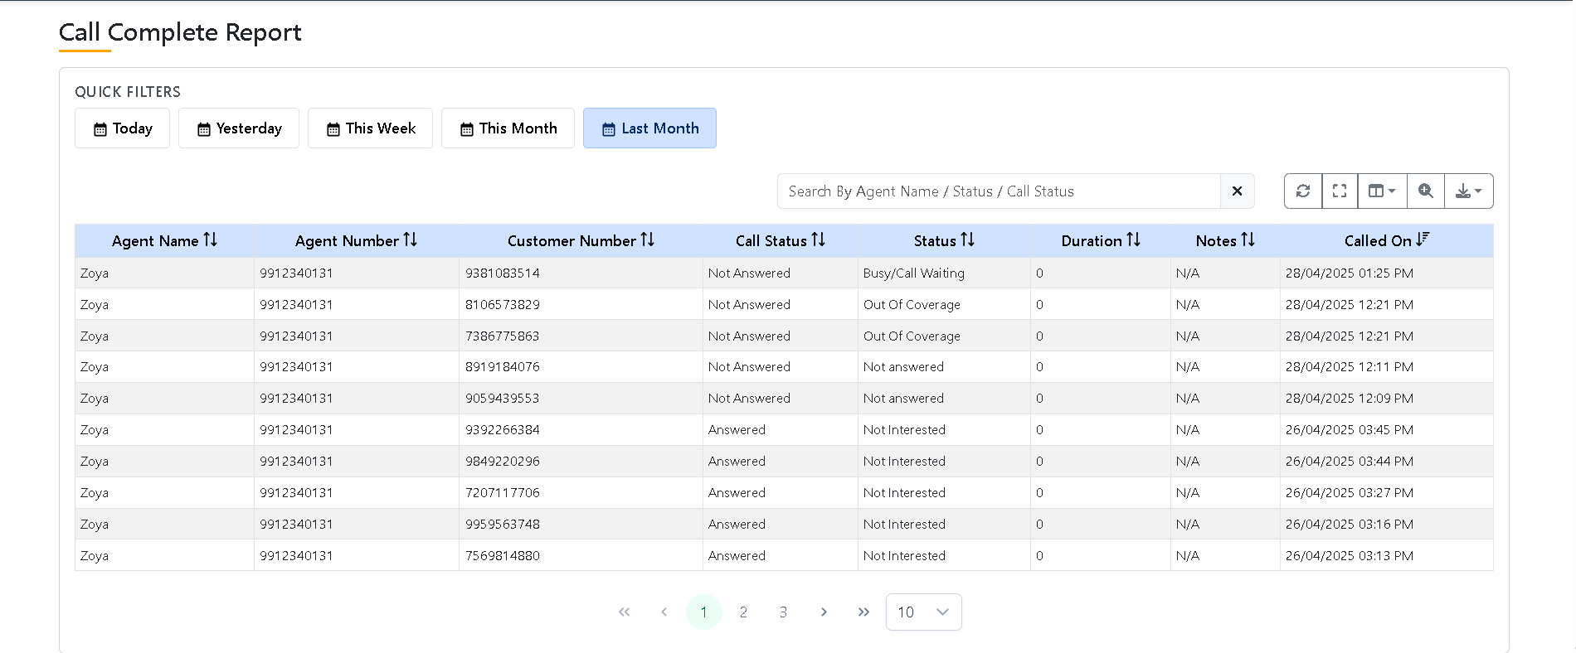

1. When we tap on View more option its viewing and closing for all the groups even though we tap on single group.



1. Warning message is showing under the pop up change that to show above the pop up.

